|  |
| --- |
| Name: **J.A. Mujeeb** |
| Student Reference Number: **10707284** |



|  |  |  |
| --- | --- | --- |
| Module Code: CNET343SL | Module Name: **Distributed Systems** | |
| Coursework Title: **Quick Weather** | | |
| Deadline Date: **9th May 2022** | | Member of staff responsible for coursework: **Mr. Pramudya Thilakaratne.** |
| Programme: **BSc (Hons) Plymouth Software Engineering** | | |
| Please note that University Academic Regulations are available under Rules and Regulations on the University website [www.plymouth.ac.uk/studenthandbook](http://www.plymouth.ac.uk/studenthandbook). | | |
| Group work: please list all names of all participants formally associated with this work and state whether the work was undertaken alone or as part of a team. Please note you may be required to identify individual responsibility for component parts.  **J.A. Mujeeb – 10707284**  **G.M.D.D. Ratnayake – 10707351**  **S.O. Perera – 10707315**  **N. S. De Alwis – 10707160**  **M. D. A. Medhavi – 10707278**  **P. P. L. Dilhani – 10709402**  ***We confirm that we have read and understood the Plymouth University regulations relating to Assessment Offences and that we are aware of the possible penalties for any breach of these regulations. We confirm that this is the independent work of the group.***  Signed on behalf of the group: **J.A. Mujeeb** | | |
| Individual assignment: ***I confirm that I have read and understood the Plymouth University regulations relating to Assessment Offences and that I am aware of the possible penalties for any breach of these regulations. I confirm that this is my own independent work.***    Signed: | | |
| Use of translation software: failure to declare that translation software or a similar writing aid has been used will be treated as an assessment offence.  I *have used/not used translation software.  If used, please state name of software………………………………………………………………… | | |
| **Overall mark _____% Assessors Initials ______ Date_________** | | |

* *Please delete as appropriateSci/ps/d:/students/cwkfrontcover/2013/14

Contents

2. Acknowledgement 5

3. Introduction to the Distributed System 5

4. Introduction to Quick Weather – 5

5. Usefulness of the application to the real-world 6

6. Scope of Project 6

6.1 Diagrams 6

6.1.1 System Diagram 7

6.1.2 Context Diagram 7

6.1.3 Use Case Diagram 8

7. Mobile Application as Client 8

8. Methodology 8

9. Database: PhpMyAdmin MySQL 8

10. Gantt Chart 9

11. Selection of Middleware 9

12. Technical Diagram 9

12.1 Overview of Technical Diagram 9

12.2 Technical Architectural Diagram 10

12.2.1 Overview of Technical Diagram 10

12.2.2 Middleware of Technical Diagram 10

12.2.3 Technical Architectural Diagram 10

13. Load Balancing 11

13.1 With Load Balancing 11

13.2 Without Load Balancing 11

14. Tolerance to Network Failure 12

15. System architectural Diagram 12

15.1 User Requirements 12

15.2 Functional Requirements – 12

16. API / Middleware Justification (Nilhan) 12

17. Software components used 12

18. Distributing the system 13

19. Issues faced and actions taken 13

20. Development phases 13

21. Tasks undertaken 14

21.1 Postman API requests and testing 14

21.1.1 Add Post Request 14

21.1.2 Login Request 15

21.2 Screenshots of the website 15

21.3 Screenshots of the Mobile Application 16

21.4 Screenshots of the Admin panel 17

21.5 Main codes of the website 17

21.6 Main codes of the mobile application 17

21.7 Main codes of the API 17

21.7.1 Controller 18

21.7.2 APIs 20

22. Future enhancement of the system 27

23. Risk assessment – 28

24. Quality plan 28

25. Summary - 28

26. Individual contribution – 28

Figure 1: System Diagram 8

Figure 2: Context Diagram 8

Figure 3: Use Case Diagram 9

Figure 4: Gantt Chart (Part 1) 10

Figure 5: Gantt Chart (Part 2) 10

Figure 6: Overview of Technical Diagram 10

Figure 7: Overview of Technical Diagram 11

Figure 8: Middleware of Technical Diagram 11

Figure 9: Technical Architectural Diagram 11

Figure 10: With Load Balancing 12

Figure 11: Without Load Balance 12

Figure 12: System Architectural Diagram 13

Figure 13: Dashboard 19

Figure 14: DesktopApplication.java part 1 19

Figure 15: DesktopApplication.java part 2 20

Figure 16: LoadPosts.java 20

Figure 17: Login.java 21

Figure 18: Controller.php 21

Figure 19: PostHasImagesController.php 22

Figure 20: UserController.php part 1 22

Figure 21: UserController.php part 2 23

Figure 22: UserController.php part 3 23

Figure 23: Api.php part 1 24

Figure 24: Api.php part 2 24

Figure 25: Channels.php 25

Figure 26: Console.php 25

Figure 27: Web.php 26

Figure 28: Authenticate.php 26

Figure 29: EncryptCookies.php 27

Figure 30: Preventrequestduringmaintenance.php 27

Figure 31: Redirectifauthenticated.php part 1 28

Figure 32: Redirectifauthenticated.php part 2 28

Figure 33: TrimStrings.php 29

Figure 34: TrustsHosts.php 29

Figure 35: Trustproxies.php part 1 30

Figure 36: trustproxies.php part 2 30

Figure 37: Verifycsrftoken.php 31

Table 1: Methodology 8

Table 2: Issues faced, and actions taken 13

Table 3: Development Phases 14

Table 4: Risk Assessment 18

Table 5: Quality Plan 18

# Acknowledgement

First and foremost, we’d like to extend our sincere gratitude towards Mr. Pramudya Thilakaratne, our module lecturer. We are extremely humbled and grateful to have been able to receive his mentorship, guidance, and support.

The overall accomplishment of this project demanded a significant amount of guidance from many individuals. As a team, we are extremely fortunate to have had this from start to finish.

Finally, we wouldn’t have been able to successfully complete this assignment without the hard work and assistance of all the team colleagues itself. We all enjoyed working with each other.

# Introduction to the Distributed System

The use of weather reporting in day-to-day life is very important. Its utilization could greatly influence the outcome of a scenario. It could be something as simple as deciding whether you should take your umbrella on your way out, or even as major as handling cultural operations, agriculture and farming or livestock protection implementations.

With Sri Lanka’s weather rapidly varying, weather can transition from largely homogeneous temperatures to torrential rain in a heartbeat. With the adaptation of unexpectedly frequent changes, it is crucial to make sure to be prepared.

Sri Lanka is liable to prevailing and predictable effects of climate change. Preceding natural disasters (such as tsunamis, floods, landslides, droughts, and cyclones) can greatly substantiate this. Profoundly weather-sensitive sectors in Sri Lanka include transport, agriculture, construction, energy, and disaster risk management.

It is important to note that even with weather stations, live broadcasts, and television/radio stations existent, not all are aware of the continuously differentiating weather conditions.

The impacts and effects of climate change could invite climate change-induced hazards and disasters. The unawareness of weather reports may affect the lives of many. Thousands of citizens are prone to being affected by the threat of climate change. They may find themselves in life threatening situations. Weather prediction is essential in order to provide citizens with pragmatic information. Furthermore, this also aids in the reduction of weather-related losses, personal safety and health, enhancement of societal benefits and in supporting economic prosperity.

It is abundantly clear that weather forecasting reports are essential to mitigate the effects civilians getting caught in a severe crisis.

# Introduction to Quick Weather –

**What is distributed system?**

A distributed system is contrived to assist the development process of services and applications. These services and applications are able to manoeuvre a physical architecture that would contain multiple independent processing elements. The processing elements do not share primary memory but do partake in complying with dispatching asynchronous messages via communication network.

We have a system or application that could be a software. In that particular system we have a number of independent computers (individual computers inside the system). These individual computers are doing their own task in the system, but for the end user this looks like one single system. Those computers are doing their own tasks but for the user, they can see everything as one system.

Furthermore, Distributed Systems also utilize independent hardware in furtherance of creating a software. It would appear as a complete system all working as a single unit, when in reality multiple computers are used in contemplation of making a distributed system function.

While the primary memory of alternative hardware elements isn’t administered by Distributed Systems, multiple independent processing elements within the hardware are utilized. With the utilization asynchronous messages, they can communicate over a networked communication.

In the following report, we would like to highlight the main outcome of our system.

To make the reader of this report get a clear idea, we have simply built a Web   
Application and Mobile Application that will be running as a client application.

The general public (users) often need to be informed on the current weather situation. Yet, as it is reckoned that Sri Lanka is still a developing country, it is only specified in either the news or radio stations.   
In normal circumstances, the user may only be able to view the weather around their current location, but with Quick Weather, any user can view the weather around the country.

Our goal is to present a high-performance Distributed Weather System that encompasses paramount customer satisfaction, convenience, imperative security, user-friendliness and maximum authenticity.

This system will present the needed weather for any planned activities in their personal lives. Furthermore, registered users have the ability to publish and access Blog Posts within the website. This feature will aid in giving any user a more visual idea on what the weather situation is like in that particular area. Blog Posts also anchor in many benefits, as it is a superb way to drive traffic to the website and also in building credibility.

# Usefulness of the application to the real-world

Quick weather can perform 02 main functions:

1. Users possess the ability to yield a weather forecast at any location within the country with the utmost accuracy and efficiency of the mobile and web application. The user simply must enter the name of the location in it to access weather details.
2. Registered users can upload and view posts about weather from the mobile and web application. This feature will aid in giving any user a more visual idea on what the weather situation is like in that area.
3. Users are able to view post descriptions by using the standalone application using NetBeans.

# Scope of Project

The following is a list of the application's scope:

* This program can predict the state of the atmosphere for a specific place. Rain, cloudiness, wind speed, and humidity are all factors.
* By checking uploaded posts (uploaded by registered users), it is possible to take precautionary steps against catastrophic rains, winds, extreme high or low temperatures, diseases, and pests.
* Distribution Scalability.
* A high-performance system that encompasses paramount customer satisfaction, convenience, imperative security, user-friendliness and maximum authenticity.
* A Desktop Application, Web Application and Mobile Application.

## Diagrams

### System Diagram



Figure 1: System Diagram

### Context Diagram



Figure 2: Context Diagram

### Use Case Diagram



Figure 3: Use Case Diagram

# Quick Weather Mobile Application

Quick Weather is created using Android Studio, the language that Android Studio uses is Java. Since Android Studio has SDKs that run emulators, it is rather quick and easy to use.

* The User can login/signup and post any type of image related to Technologies used:
* Java in the Quick Weather application
* MySQL for the database

# Methodology

|  |  |  |
| --- | --- | --- |
| **Keyword** | **Category** | **Description** |
| Java NetBeans | IDE | Utilized for the standalone Desktop Application. |
| PHP Laravel | Framework | Used for the API construction and Web Application Development. |
| PHP Laravel | Load Balancer | Distributes the web traffic amongst two or more servers and are often used for websites which receive high volumes of traffic. |
| Android Studio | IDE |  |
| Java |  |  |
| MySQL | IDE |  |

Table 1: Methodology

# Database: PhpMyAdmin MySQL

As PHP is utilized to code the Web Application, it was more coherent to utilize PhpMyAdmin for MySQL database management. PhpMyAdmin is an open-source third-party software tool, written in PHP. The primary objective of utilizing phpMyAdmin is to superintend and operate the administration of MySQL over the web. It is also feasible to run CRUD operations like databases, copy, tables, rename, databases, tables, columns, etc. phpMyAdmin can run on any server or any OS as it has a web browser. With the utilization of phpMyAdmin, it is possible to edit, create or delete the database without much difficulty. In collation to the MySQL command-line editor, it is easier to manage elements with the utilization of the phpMyAdmin graphical interface. Several servers can also be operated simultaneously. Data can also be exported into various formats like Word, PDF, SQL, XML, Spreadsheet, etc.

# Gantt Chart

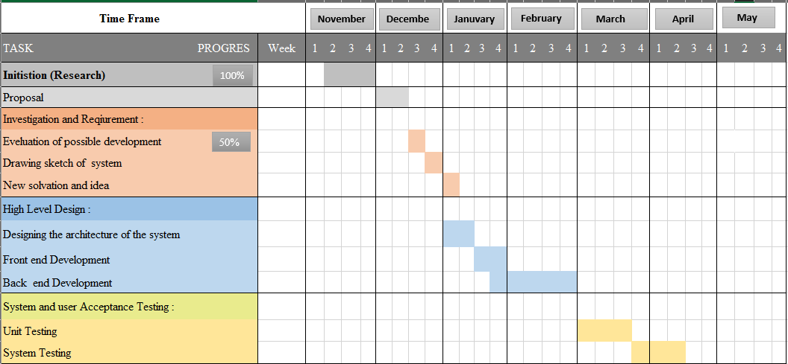

Figure 4: Gantt Chart (Part 1)

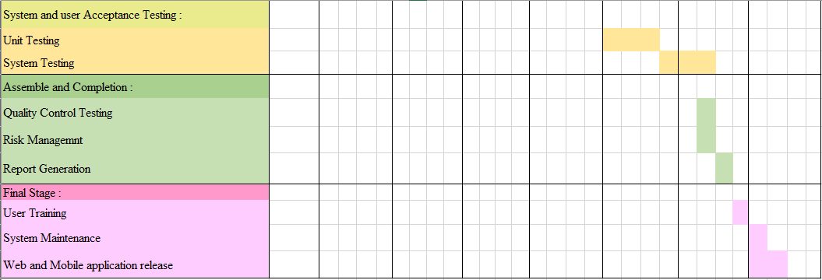

Figure 5: Gantt Chart (Part 2)

# Selection of Middleware

# Technical Diagram

## Overview of Technical Diagram



Figure 6: Overview of Technical Diagram

## Technical Architectural Diagram

### Overview of Technical Diagram



Figure 7: Overview of Technical Diagram

### Middleware of Technical Diagram

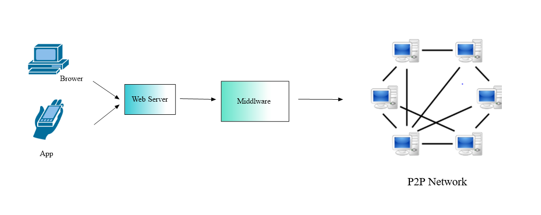

Figure 8: Middleware of Technical Diagram

### Technical Architectural Diagram



Figure 9: Technical Architectural Diagram

Our system contains a mobile app and a web app, and their total processing is made more efficient by a load balancer, which divides incoming network traffic across a cluster of three dispersed servers.

# Load Balancing

A load balancer sits in front of your servers, acting as a "traffic cop," directing client requests across all servers capable of satisfying those requests in a way that maximizes performance and reformulation testing while ensuring that no single server is overworked, potentially degrading performance. The load balancer transfers traffic to the remaining online servers if a single server goes down. When a new server is added to a server group, the load balancer begins sending requests to it automatically.

A load balancer accomplishes the following tasks in this manner:

* Client requests or network load are efficiently distributed among numerous servers.
* Sends requests exclusively to online servers, ensuring high availability and reliability.
* Provides the flexibility to add or remove servers as need dictates.

## With Load Balancing

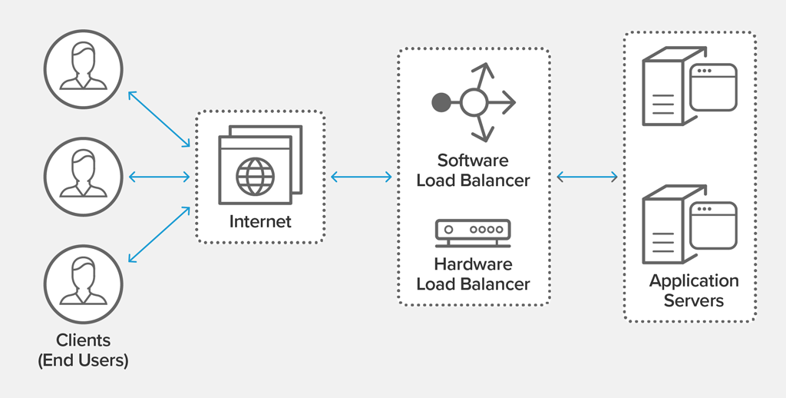

Figure 10: With Load Balancing

## Without Load Balancing

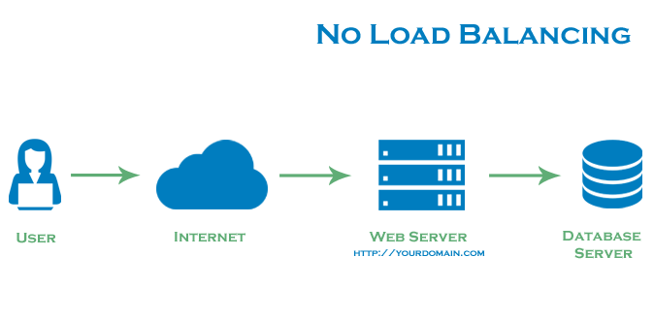

Figure 11: Without Load Balance

# Tolerance to Network Failure

As our system run in 3 servers beside the load balancer, just in case of a network failure it automatically masses to the backup server, thus no network failures can influence the system function.

# System architectural Diagram



Figure 12: System Architectural Diagram

## User Requirements

The Graphical User Interface system is designed in a way where the user can:

* Users can check weather without having to sign up/sign into the system.
* The users just must enter the city name of the preferred place where they want to know the weather of.
* The weather will be displayed in an instance for the user to view.
* Users also can check posts that are posted by other members of society.

## Functional Requirements –

* We tend to run multiple copies of each element on totally different machines.
* Data is replicated in order to avoid single machine failure. In this way, loss of data can be avoided.
* The system runs elements on separate machines.
* Has redundancy at all layers.

# API / Middleware Justification (Nilhan)

# Software components used

* Laravel – Laravel was used to create the API for the system, this is a free, open-source web framework that is used for web application development. It follows a model-view-controller design pattern.
* MySQL – Open-source relational database management system, it uses Structured Query Language, one of the most famous languages for managing content in a database.
* Android Studio – Android Studio is a mobile application development platform; Android Studio has their own emulators which makes it easy for developers to use and maintain. Android studio has fast execution, which provides time effectives for developers.
* NetBeans – integrated development environment for Java. NetBeans was used to create our stand-alone application.

# Distributing the system

* Distributed File System

# Issues faced and actions taken

|  |  |
| --- | --- |
| **Issues Faced** | **Actions Taken** |
|  |  |

Table 2: Issues faced, and actions taken

# Development phases

|  |  |
| --- | --- |
| **Development phases** | **Description** |
| 1. Planning | When it comes to defining a project's boundaries, it is mandatory to consider the potentiality of how largesse the scope can be.  By composing a project plan, a calculation of the spatial sense (timeliness) of the project will be incited. This will include a breakdown of possible tasks, a conclusion of the inherent deadlines and overall time taken to complete the tasks. All necessary requirements are accumulated to determine the sequencing the work, including a creation of an initial project schedule. |
| 2. Analysis | The analysis stage will decipher the system's critical features and requirements. This will establish whether it is worthwhile to develop.  It will also determine a requirement of the possible tools and technologies to be utilized, a potential project schedule, necessary budget estimations, etc. |
| 3. Designing | Designing will aid in roughly determining the shape and form of what must be assembled. It will be utilized in the form of a template. This will dictate the implementation proceedings, software architecture, database, and frontend designs**.** |
| 4. Coding and debugging | Frontend development, Database development, Website creation, and the implementation and development of backend logical coding has been contrived. Correspondingly, a Mobile Application with implemented logical coding and a frontend is generated. In addition, an API to interface and a MySQL database has been created. |
| 5. Testing | Functional testing is executed to see if we are achieving the expected and needed outcomes. All code units in the project have been tested, closely following the unit testing process. Integration Testing has been conducted after Once the system's modules were integrated, the full system was effectuated with end-to-end testing. We have also exercised User Interface Testing. This process would entail checking whether the UIs have been designed in fulfilment of the system's specifications. Furthermore, Load Testing has been carried out within the confines of non-functional testing to emphasise the system's overall quality. |
| 6. Deliver the product | In the final development stage, the website, mobile application and report is completed and presented. |

Table 3: Development Phases

# Tasks undertaken

## Postman API requests and testing

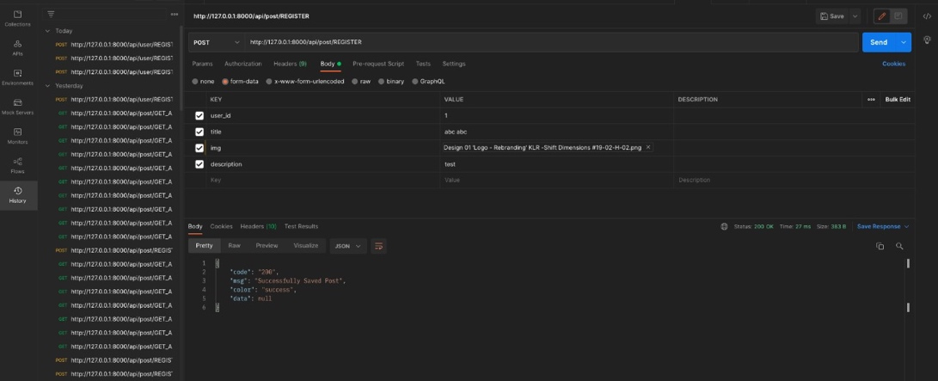

### Add Post Request

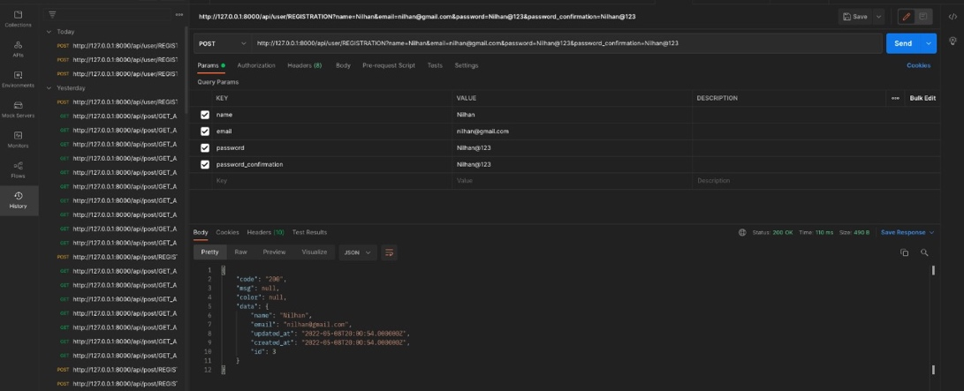

### Login Request

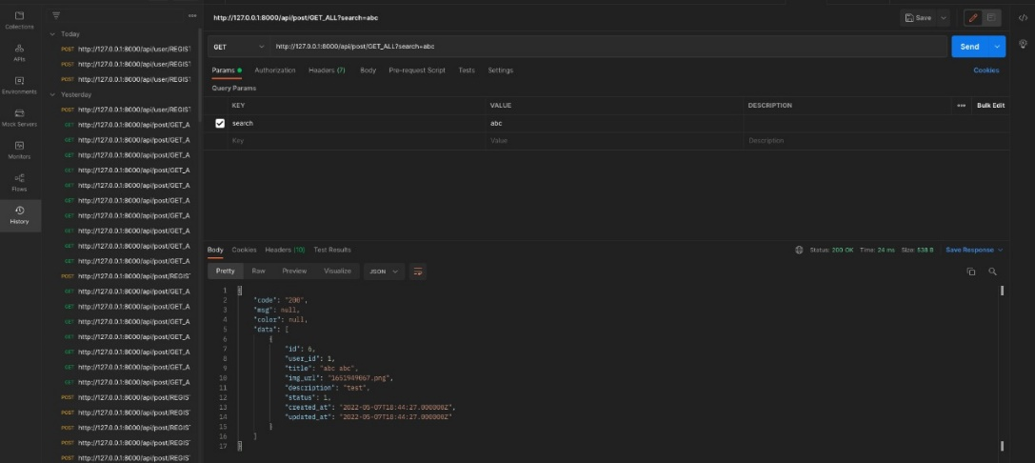

## Screenshots of the website

The web application as shown below is the interface the user is greeted with when

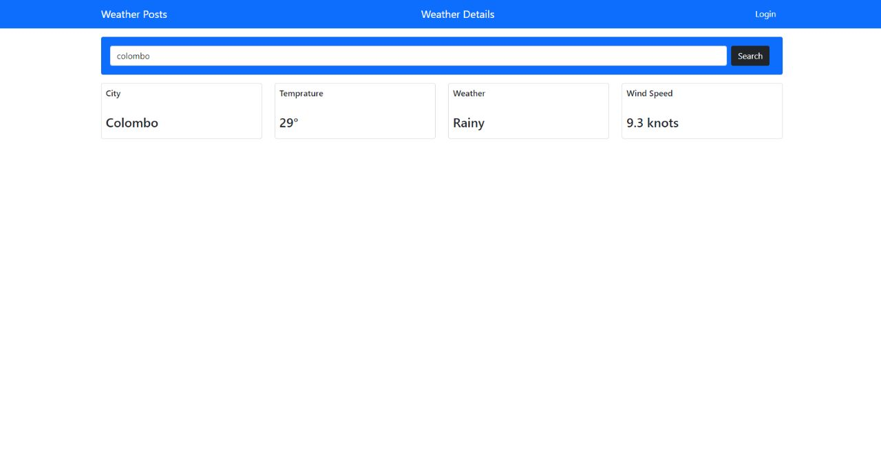

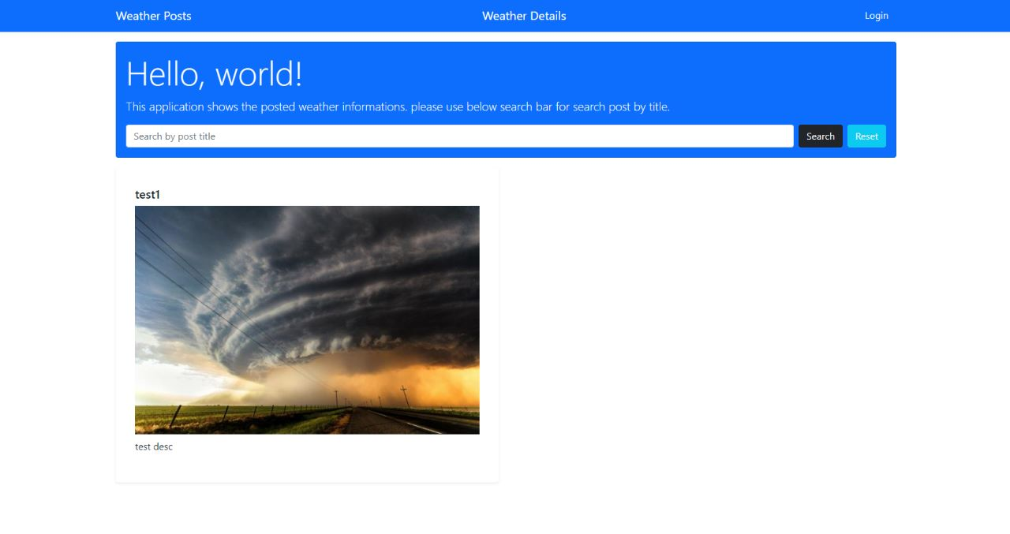

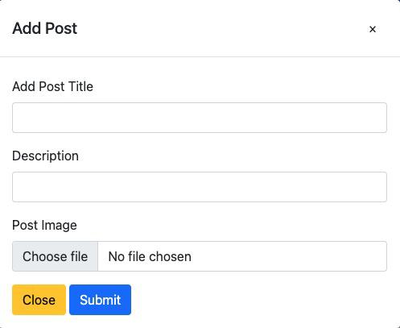

## Screenshots of the Mobile Application

This is the interface the client is greeted with when he/ she is in need of creating an account to gain privileges of posting updates on the weather post page on the web page of this distributed application.

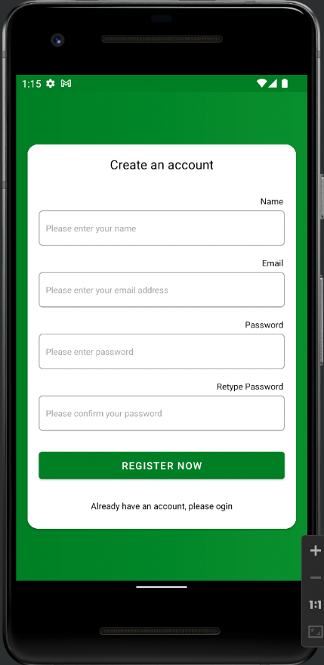

After the user creates an account, he or she can login through the app to see the weather-related posts that have been submitted as shown below

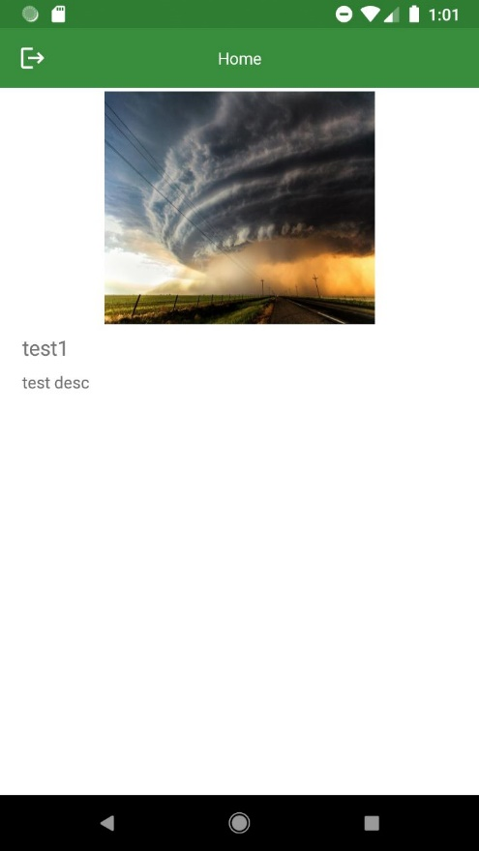

This is the user login page where he or she enters their email and password to login to the app to view the posts.

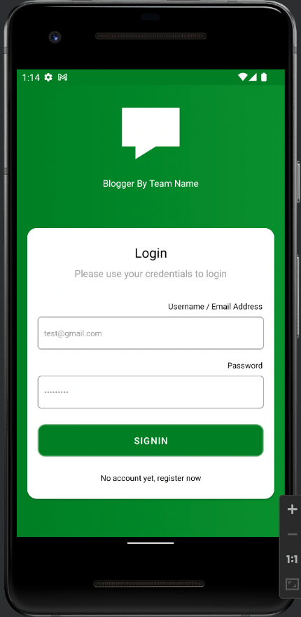

## Main codes of the website

## Main codes of the mobile application

Main activity is where the code responsible for the temporary splash screen is visible as you access the mobile application.

### Create an account mobile application code

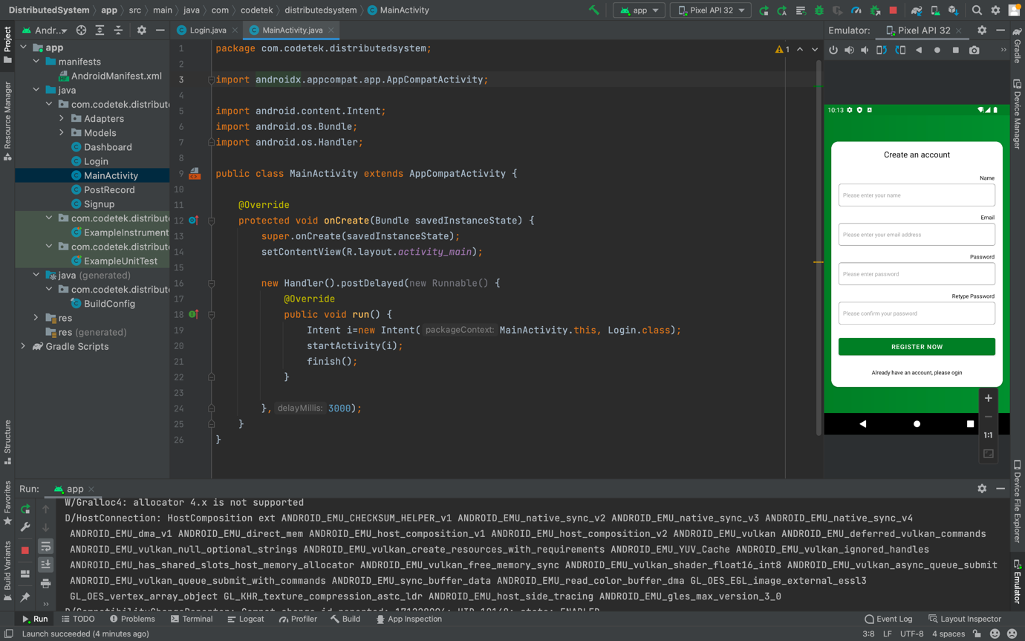Figure 13: Create an account

### Login

Login screen code is present in this code view as shown with the running interface in the right side of the screen shot.

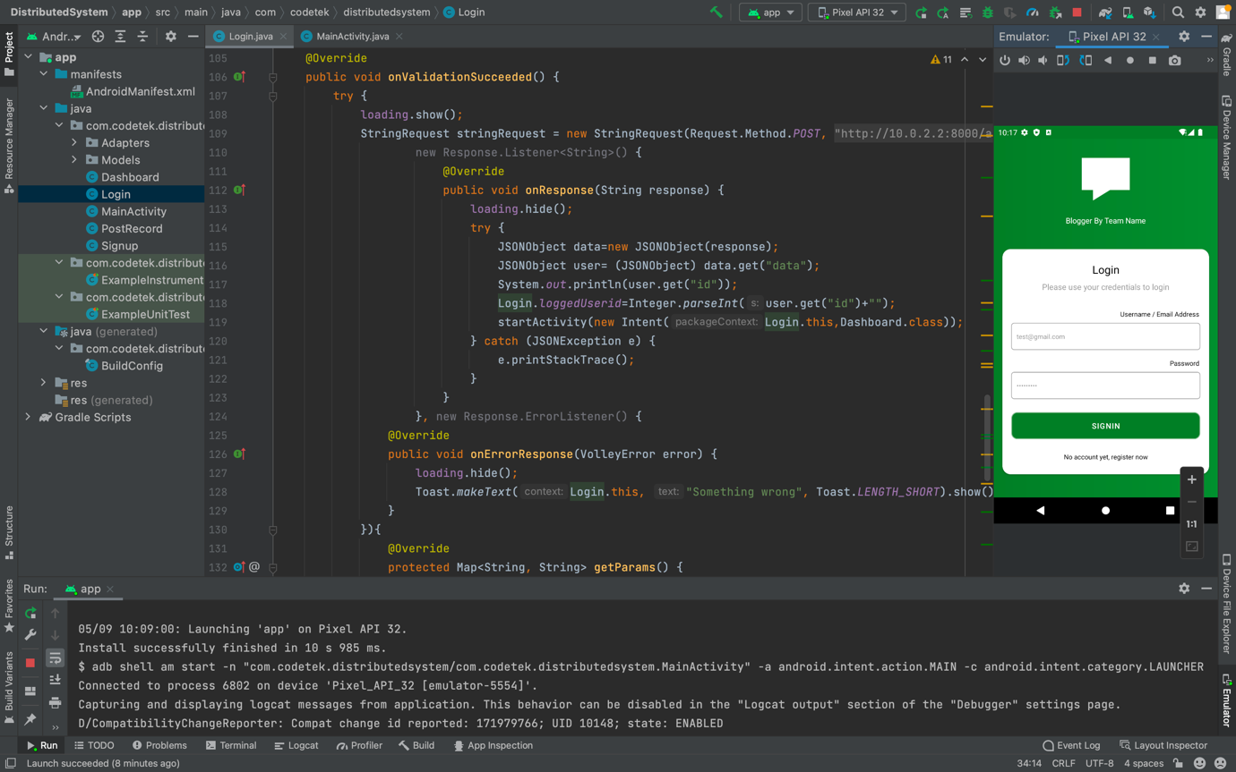

Figure 14: Login code

### Dashboard

This shows the code responsible for the post page in the mobile view where the user can view the posts.

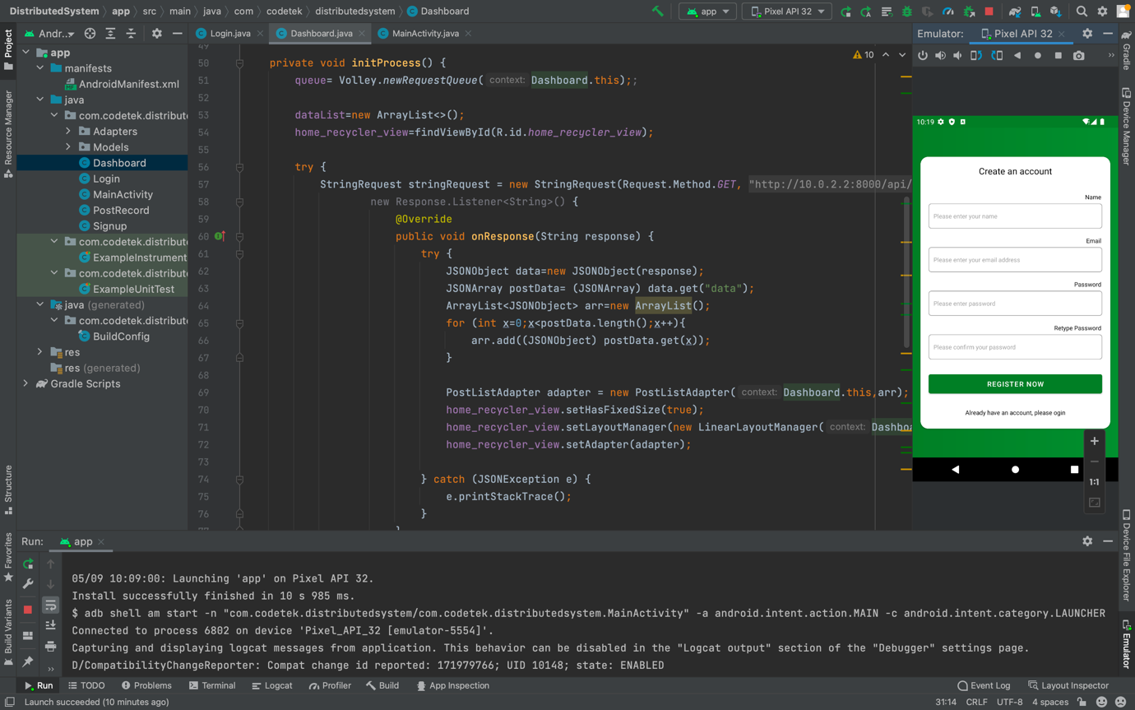

Figure 15: Dashboard Code

### Post records

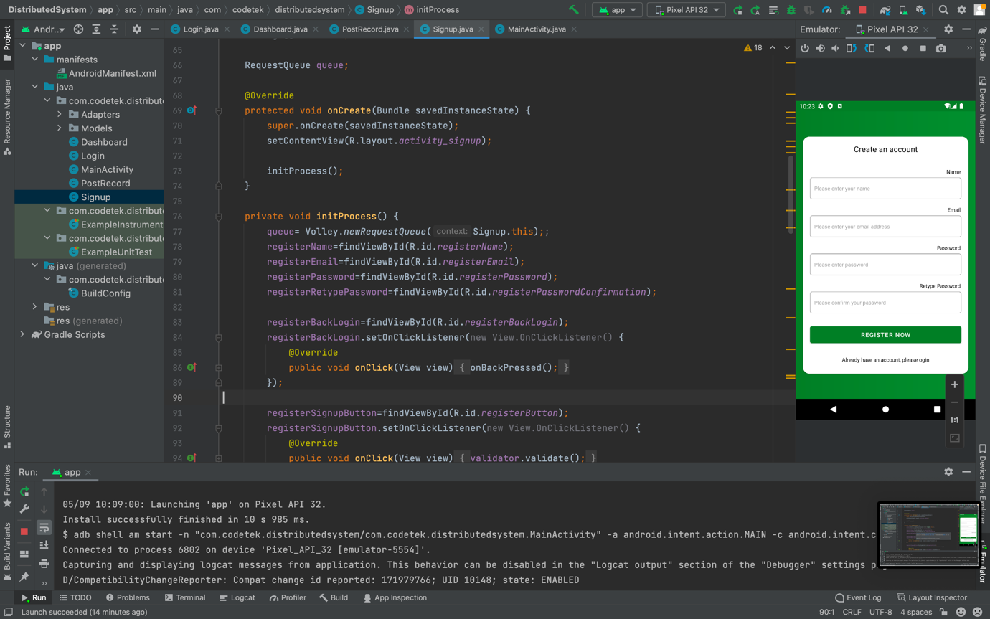Figure 16: Post Screen page

### Signup Screen

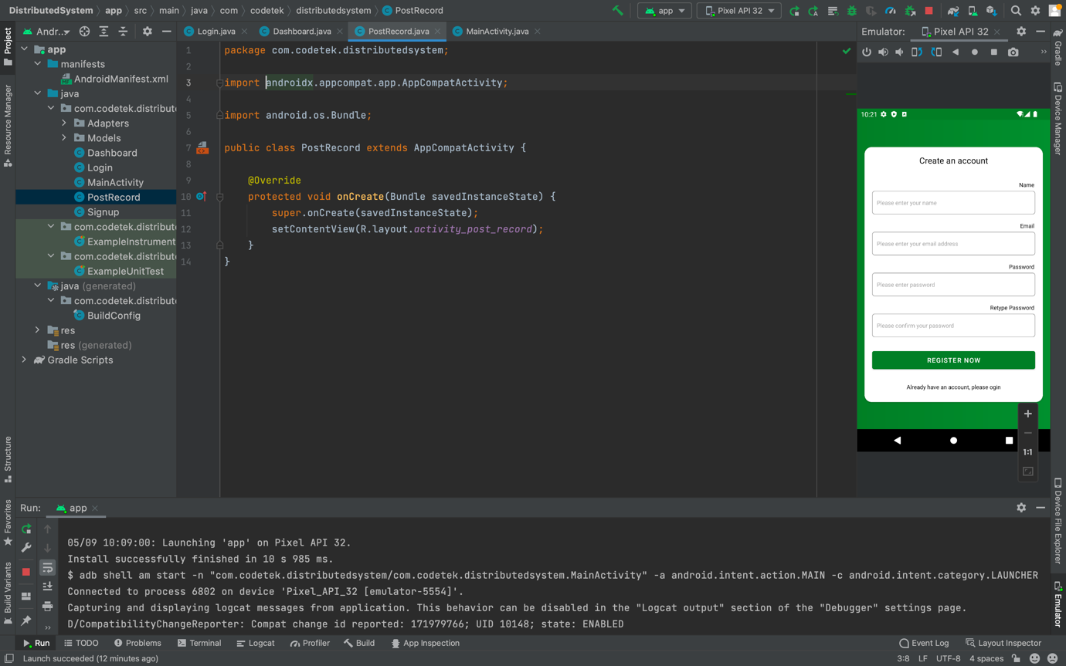

Figure 17: Sign up screen page

## Main codes of the Desktop application

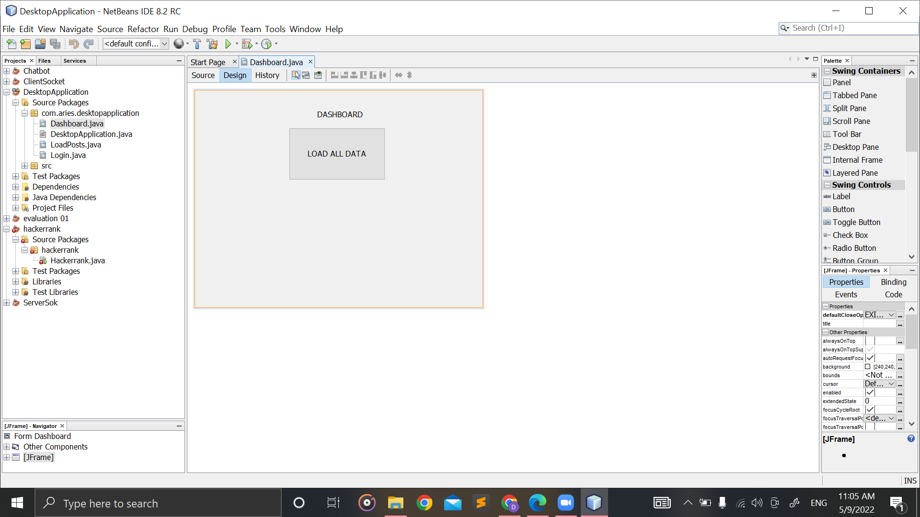

Figure 18: Dashboard

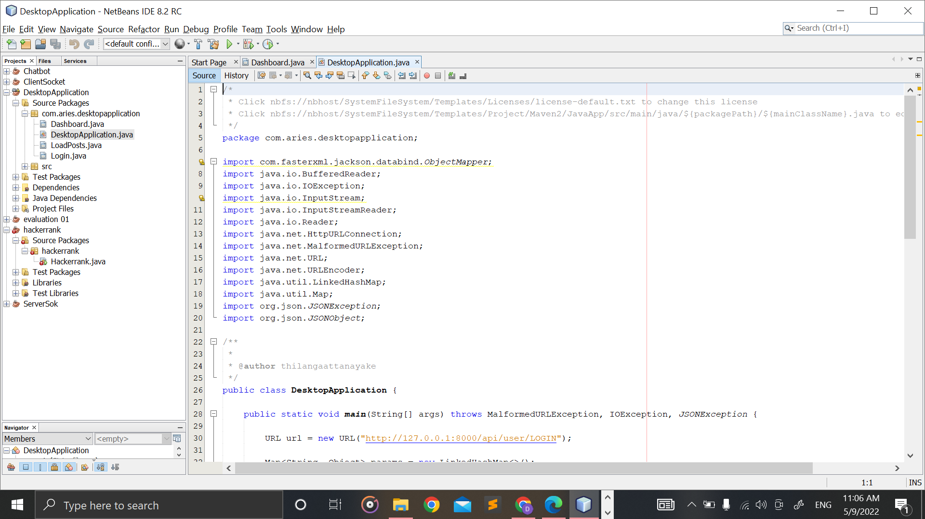

Figure 19: DesktopApplication.java part 1

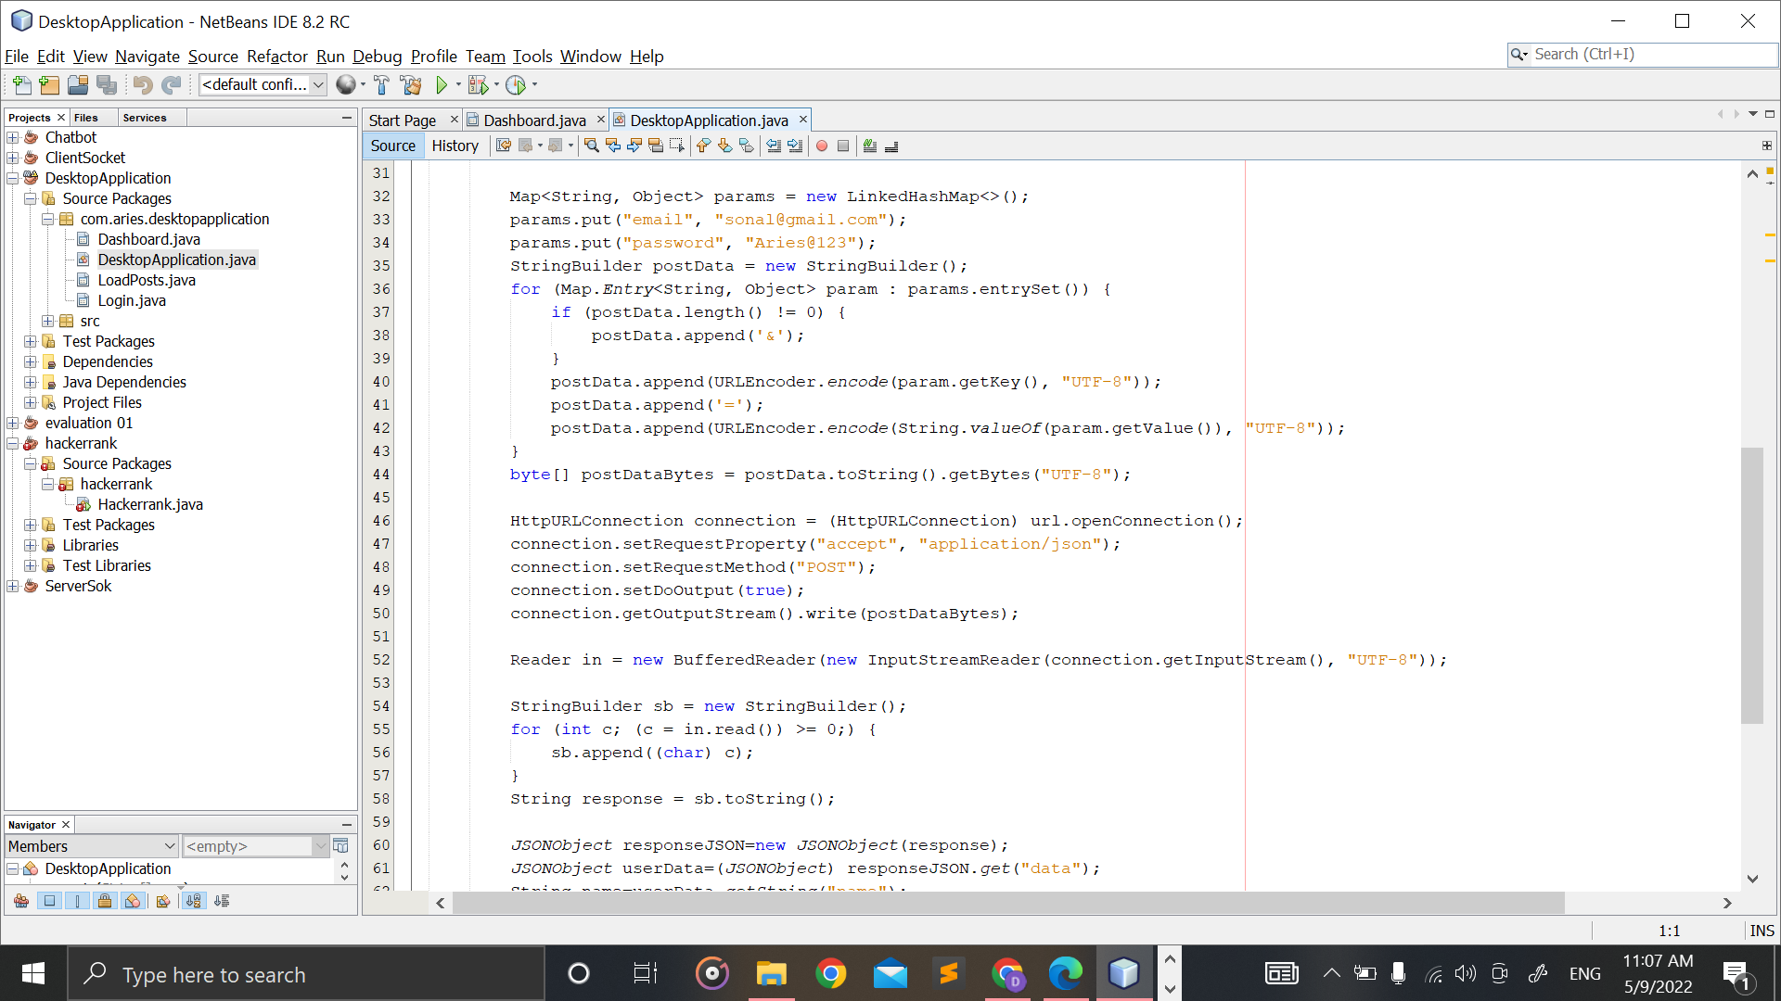

Figure 20: DesktopApplication.java part 2

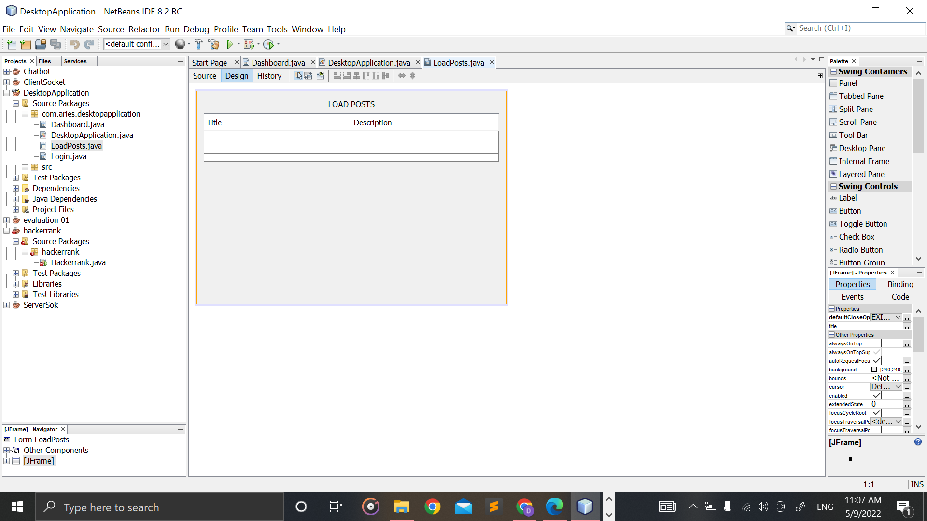

Figure 21: LoadPosts.java

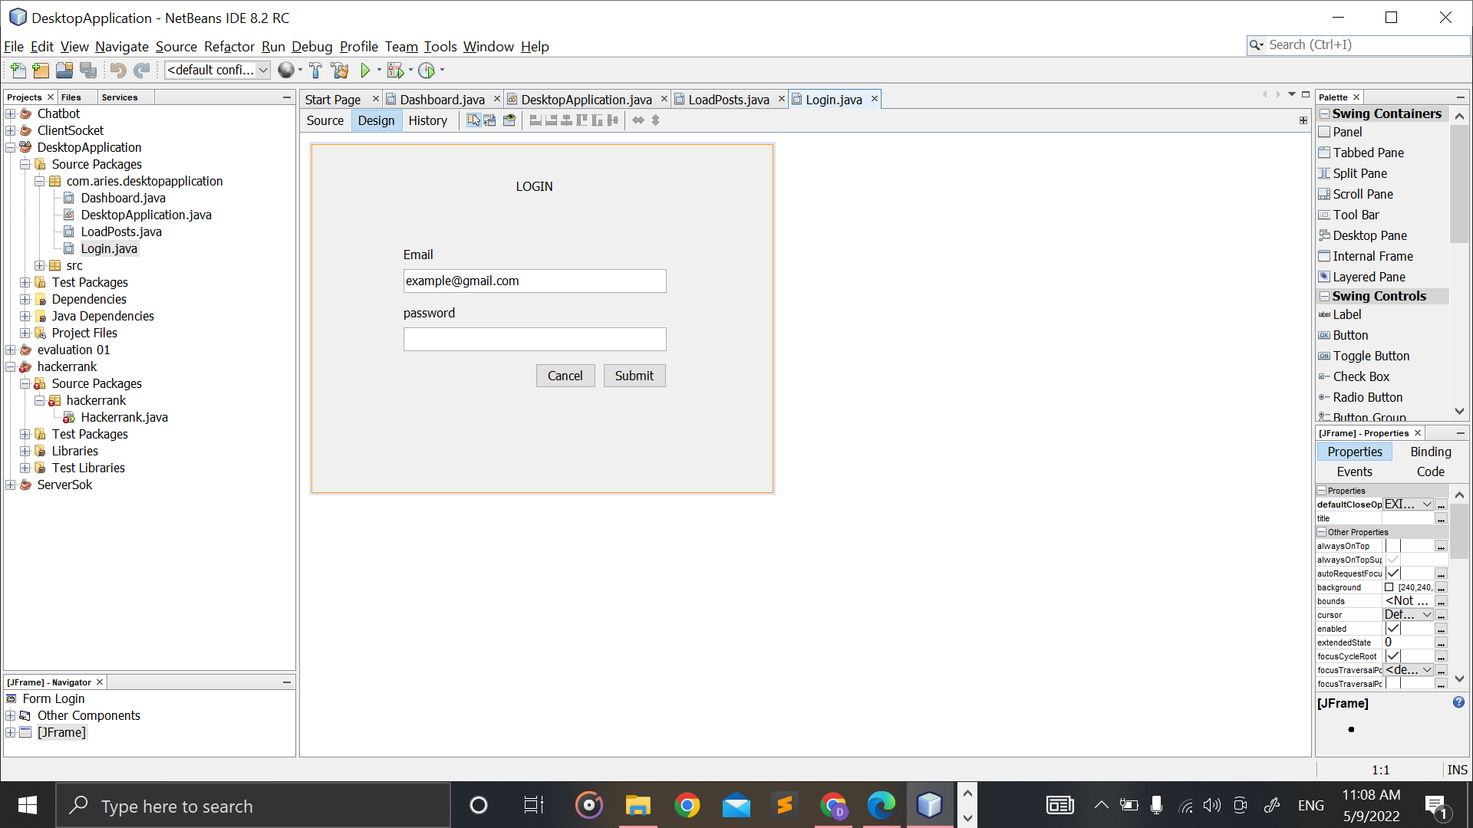

Figure 22: Login.java

## Main codes of the API

### Controller

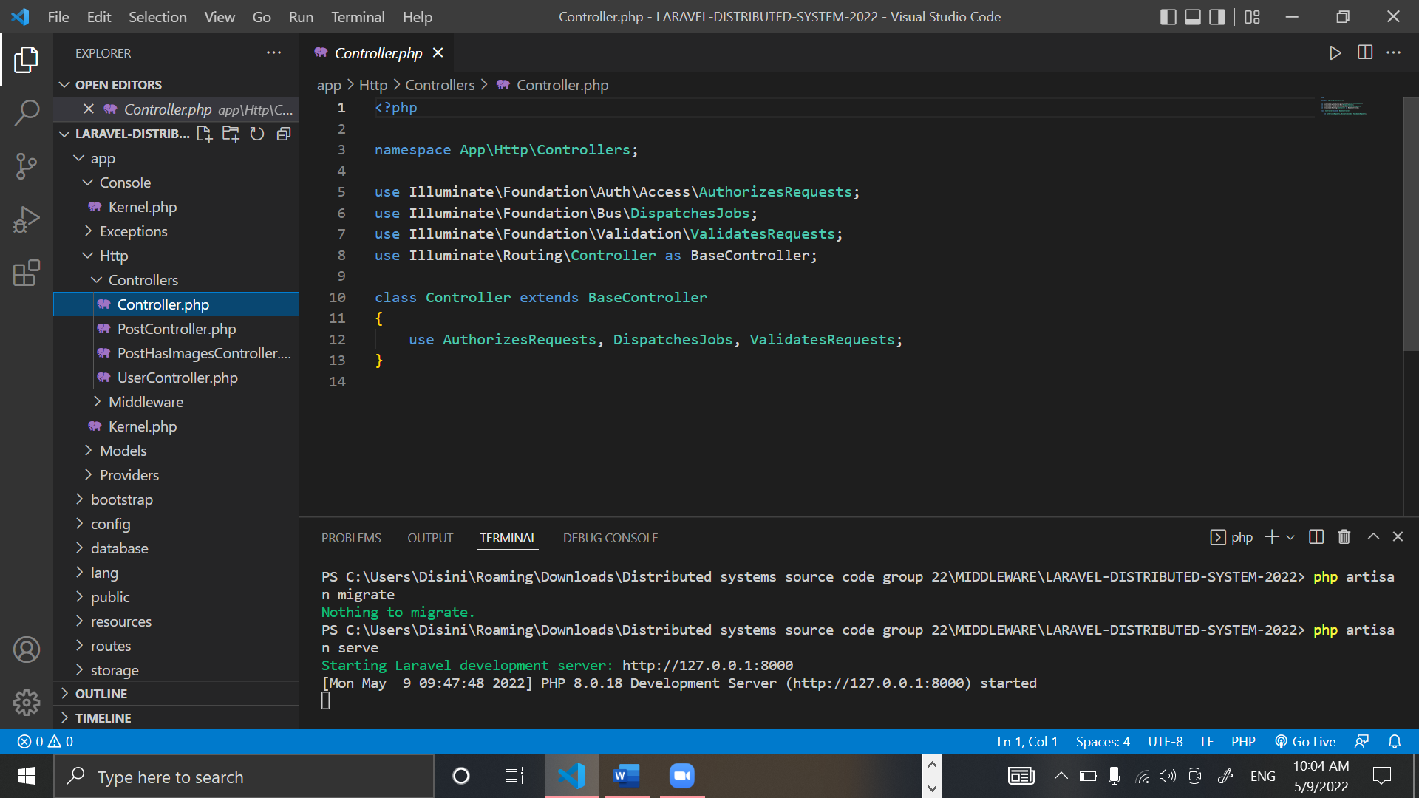

Figure 23: Controller.php

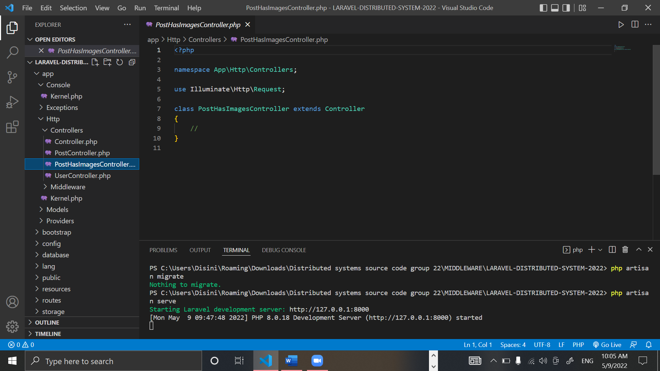

Figure 24: PostHasImagesController.php

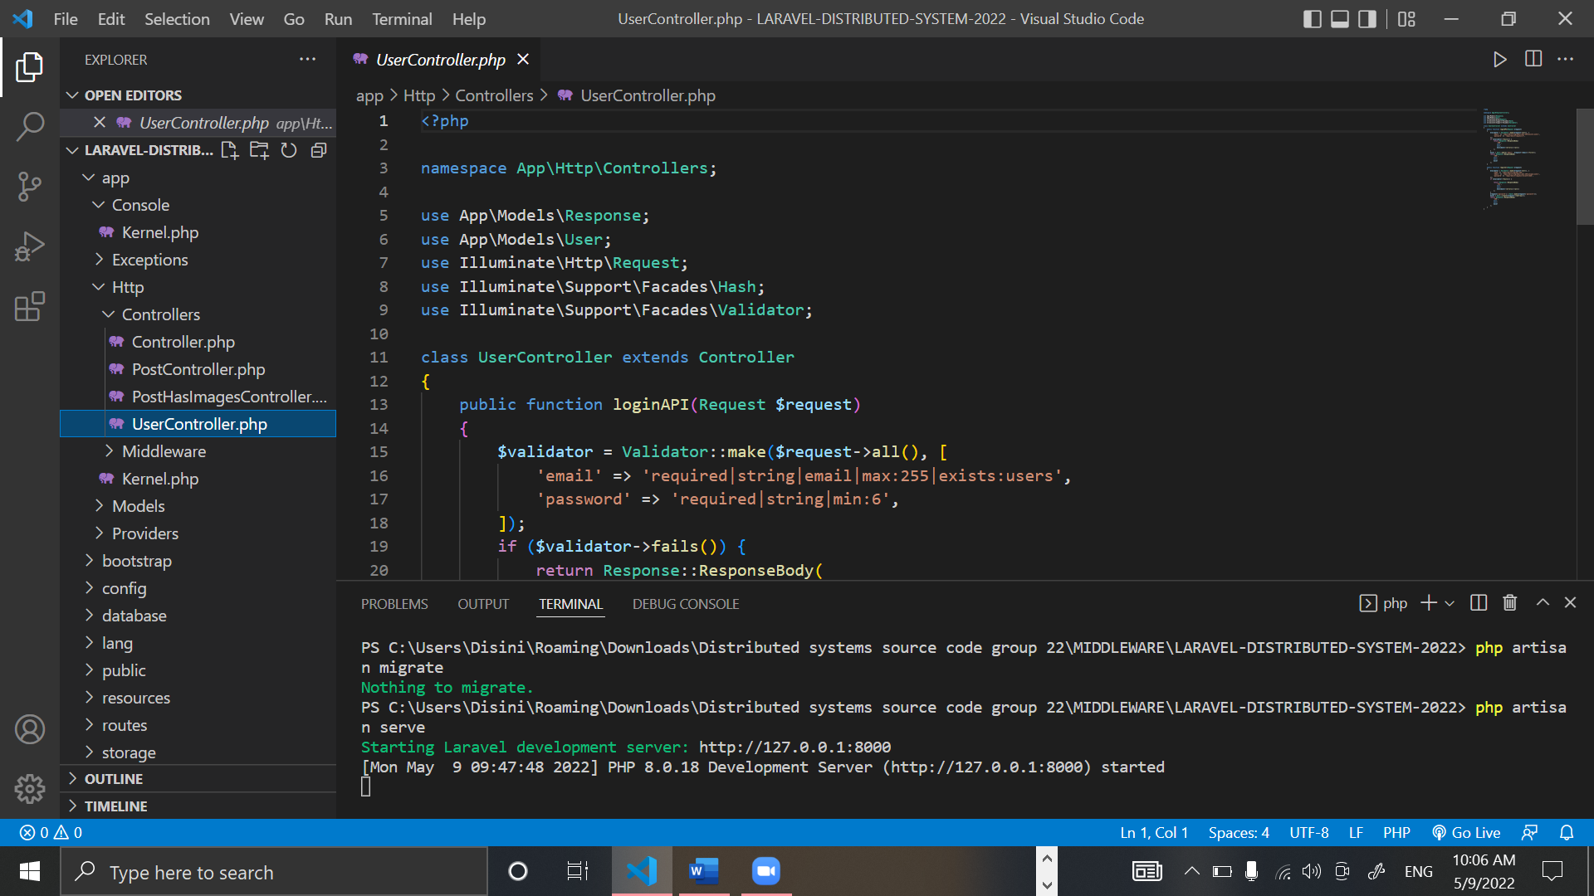

Figure 25: UserController.php part 1

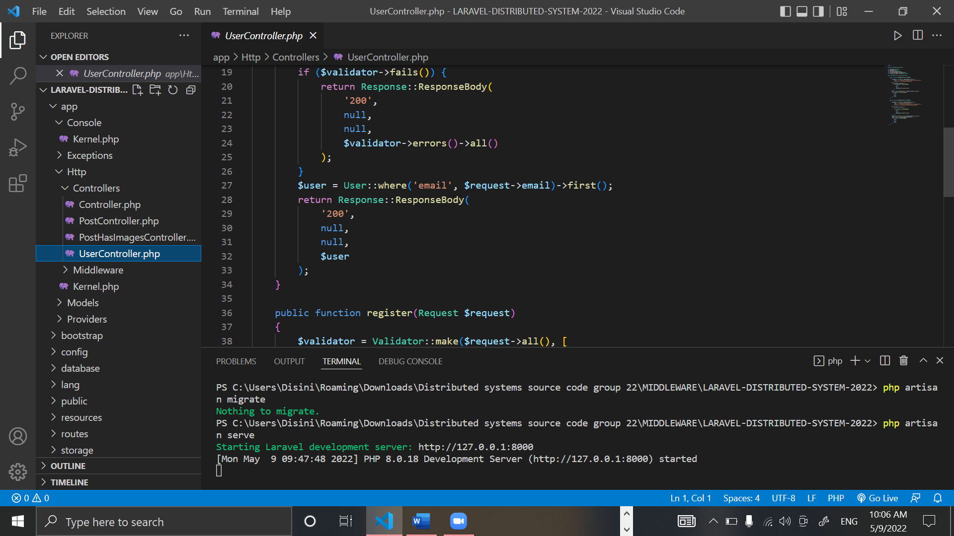

Figure 26: UserController.php part 2

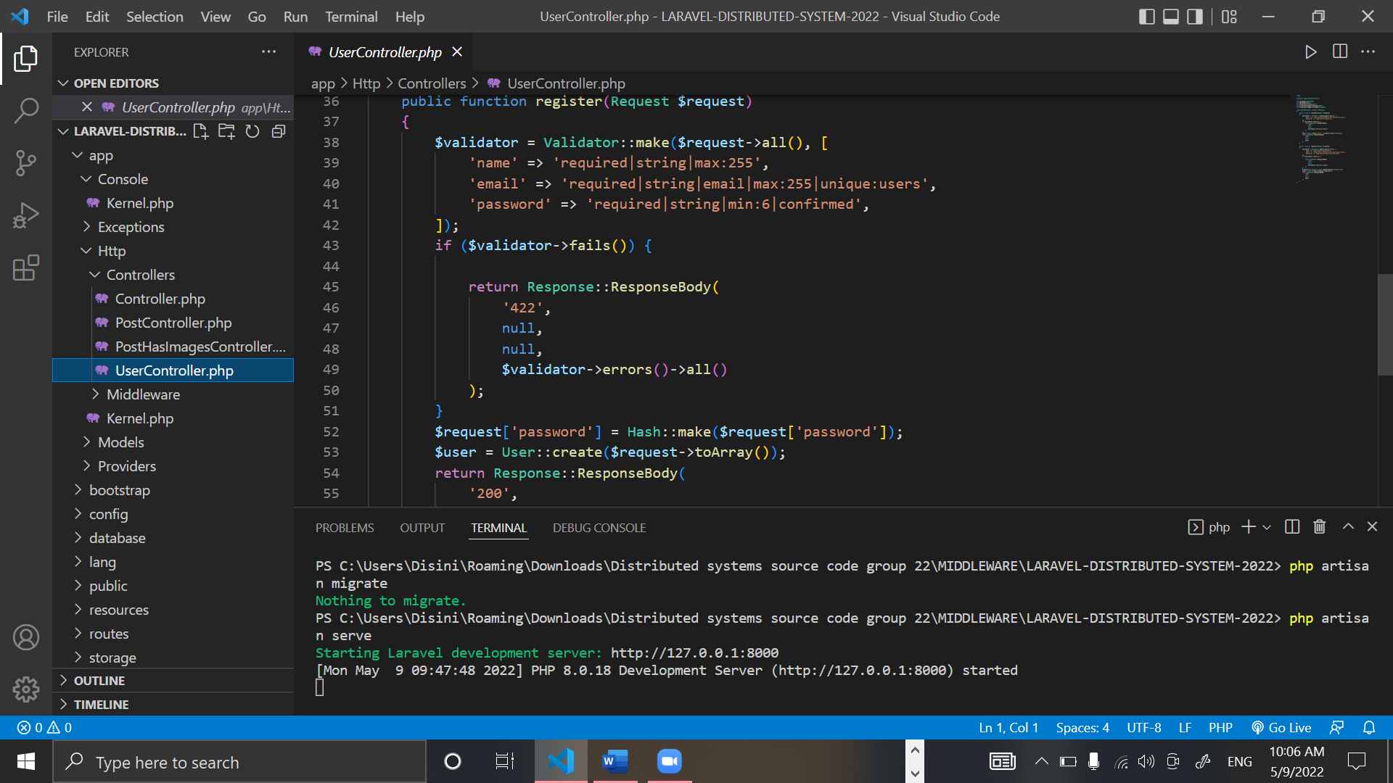

Figure 27: UserController.php part 3

### APIs

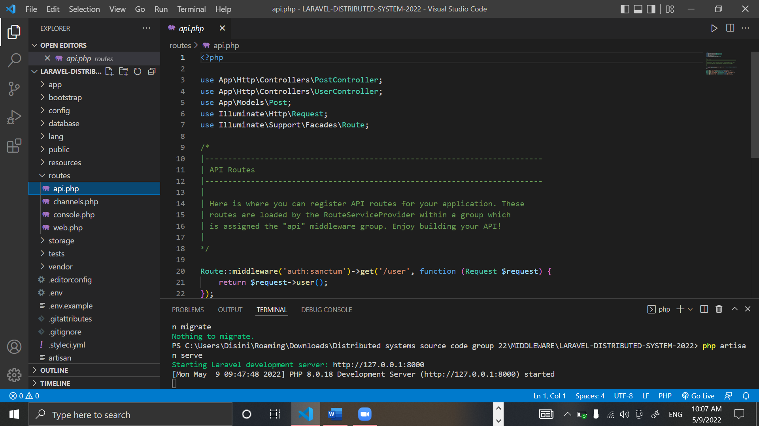

Figure 28: Api.php part 1

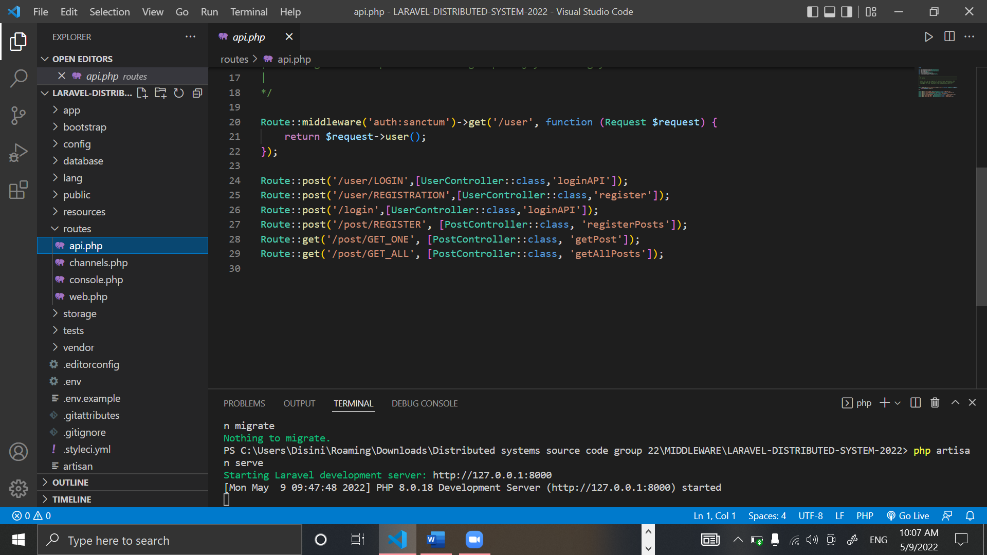

Figure 29: Api.php part 2

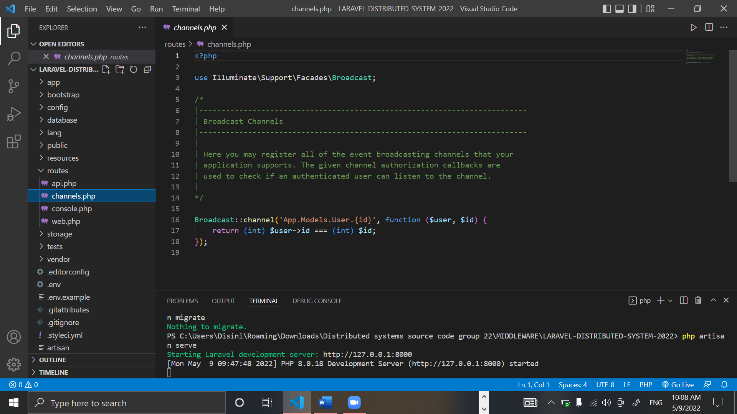

Figure 30: Channels.php

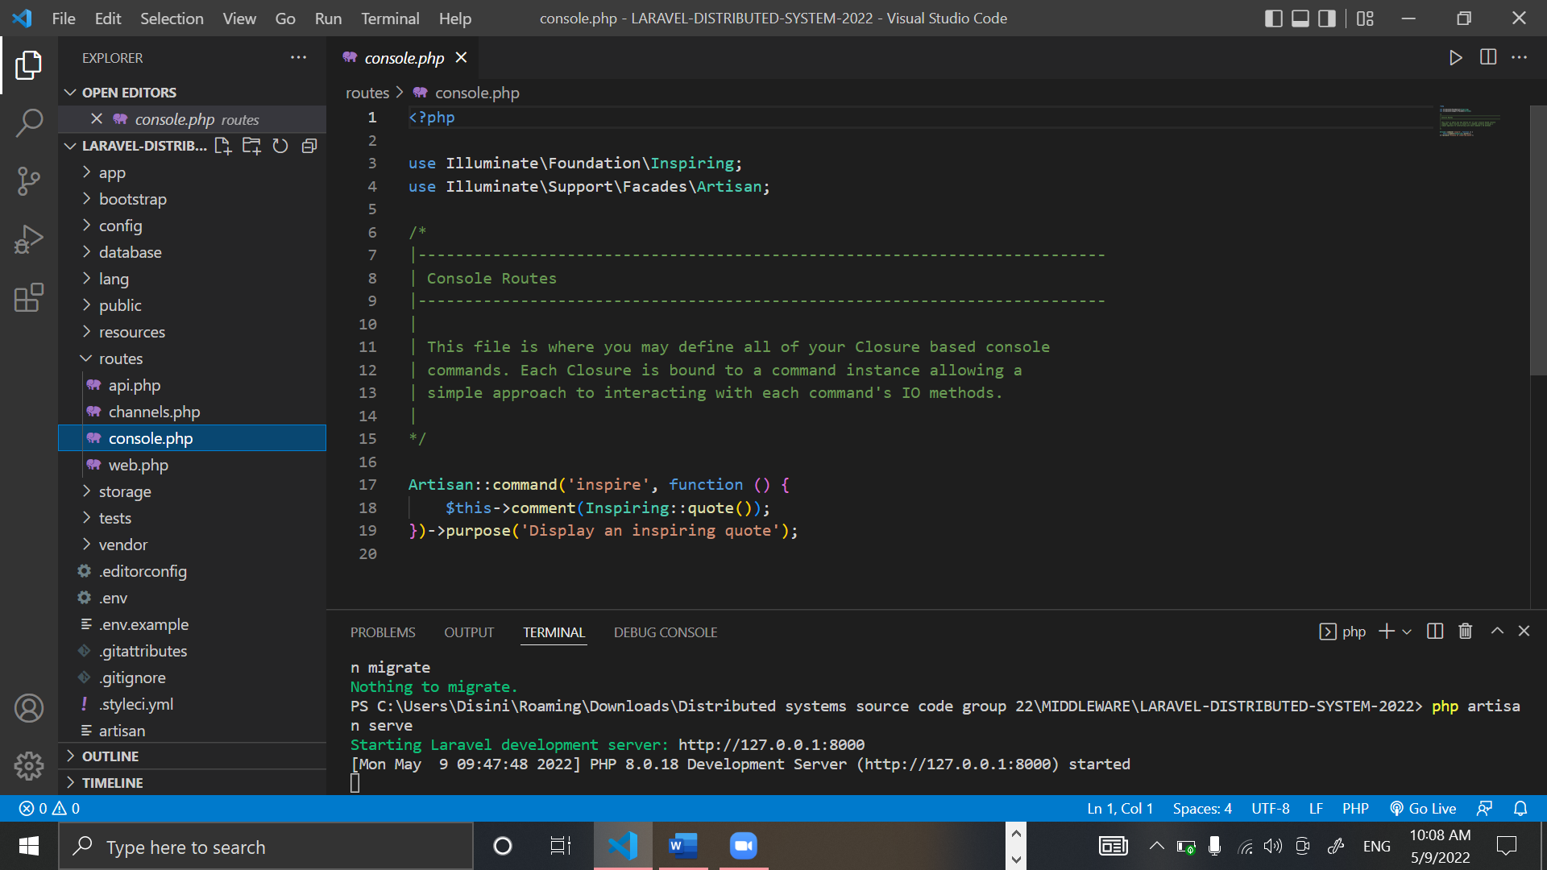

Figure 31: Console.php

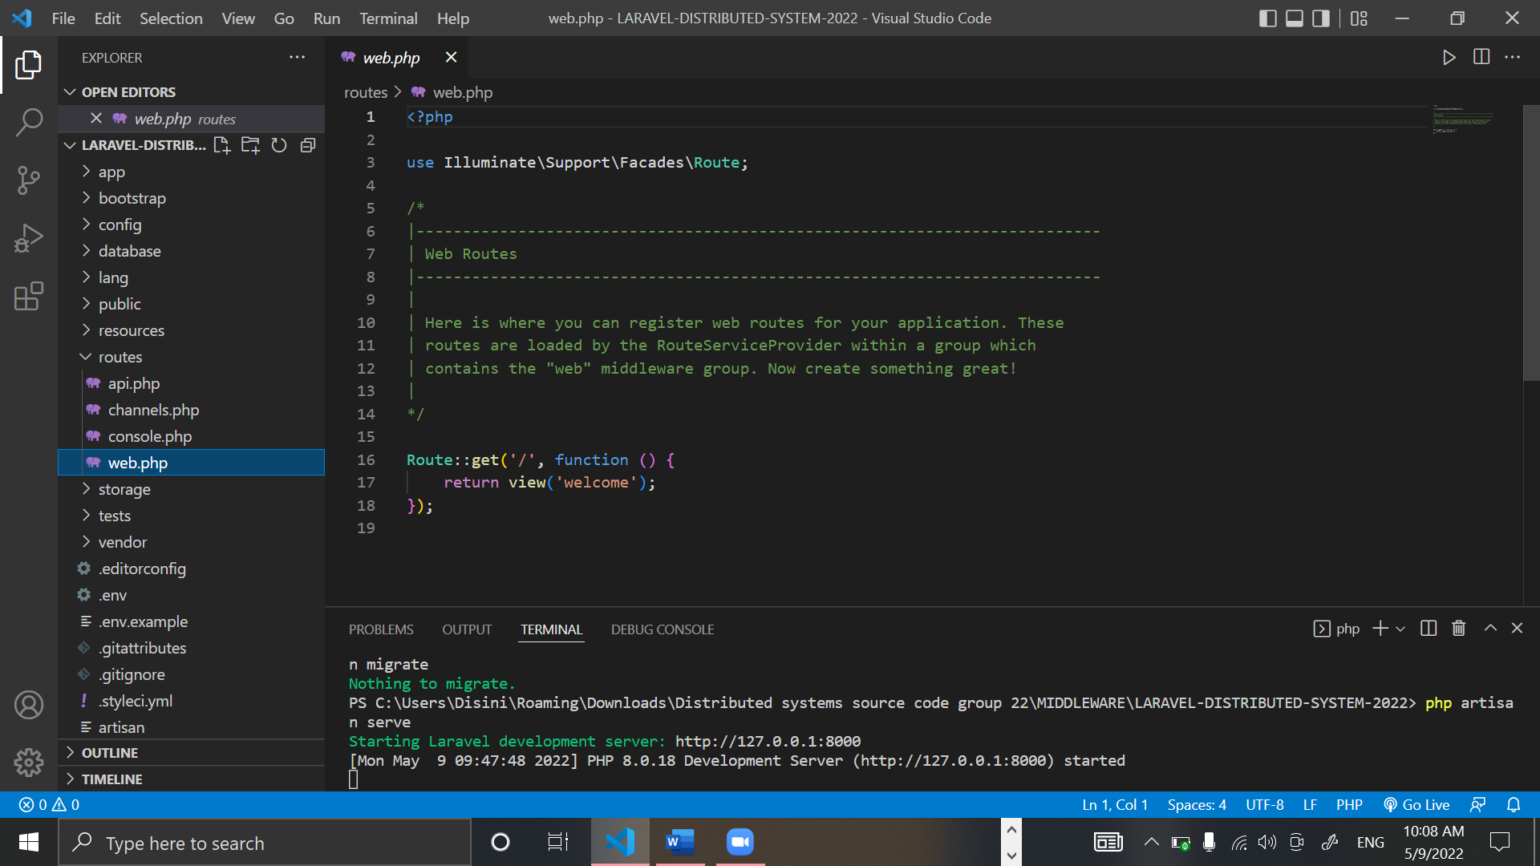

Figure 32: Web.php

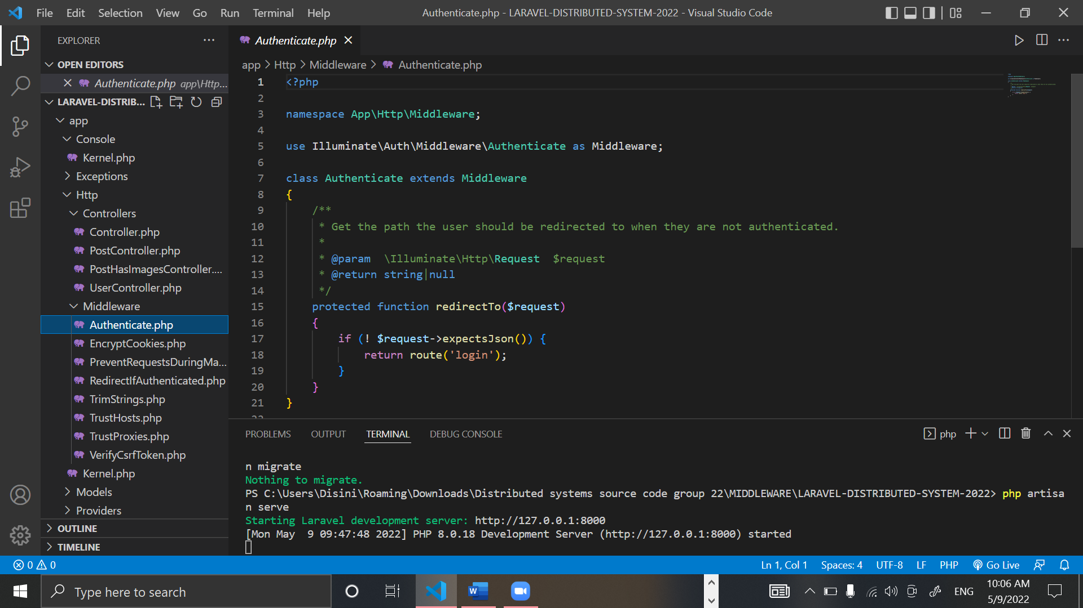

Figure 33: Authenticate.php

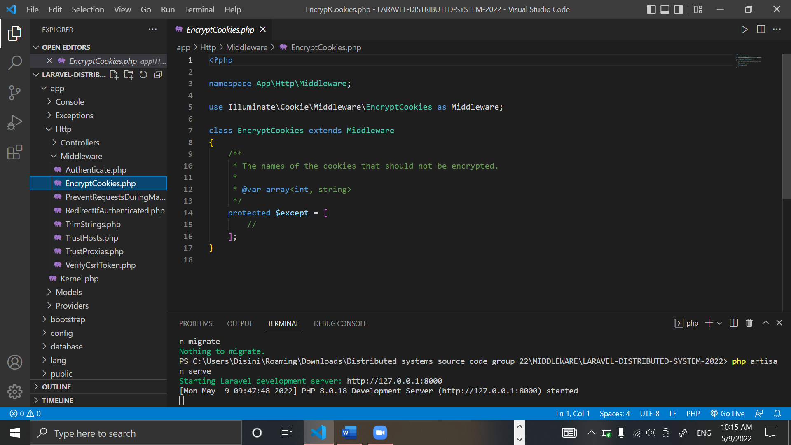

Figure 34: EncryptCookies.php

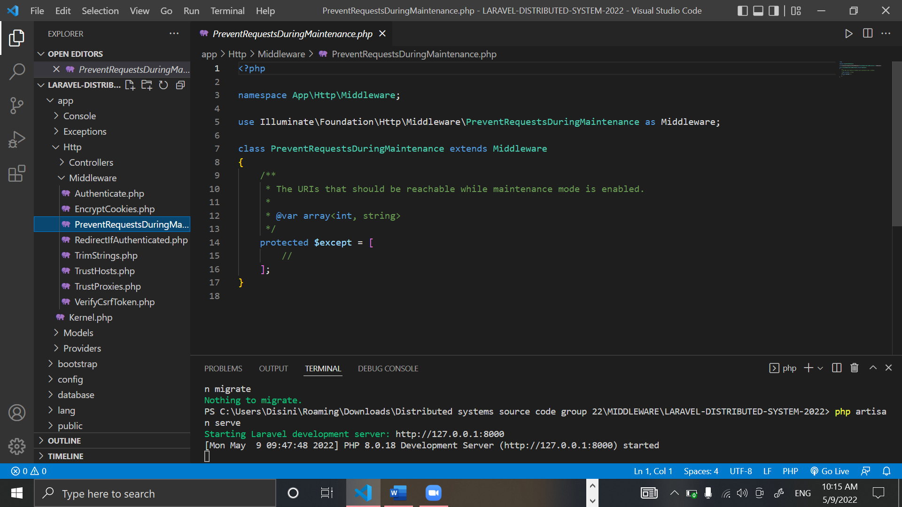

Figure 35: Preventrequestduringmaintenance.php

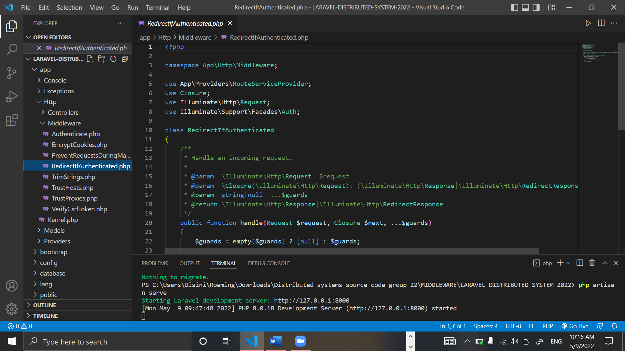

Figure 36: Redirectifauthenticated.php part 1

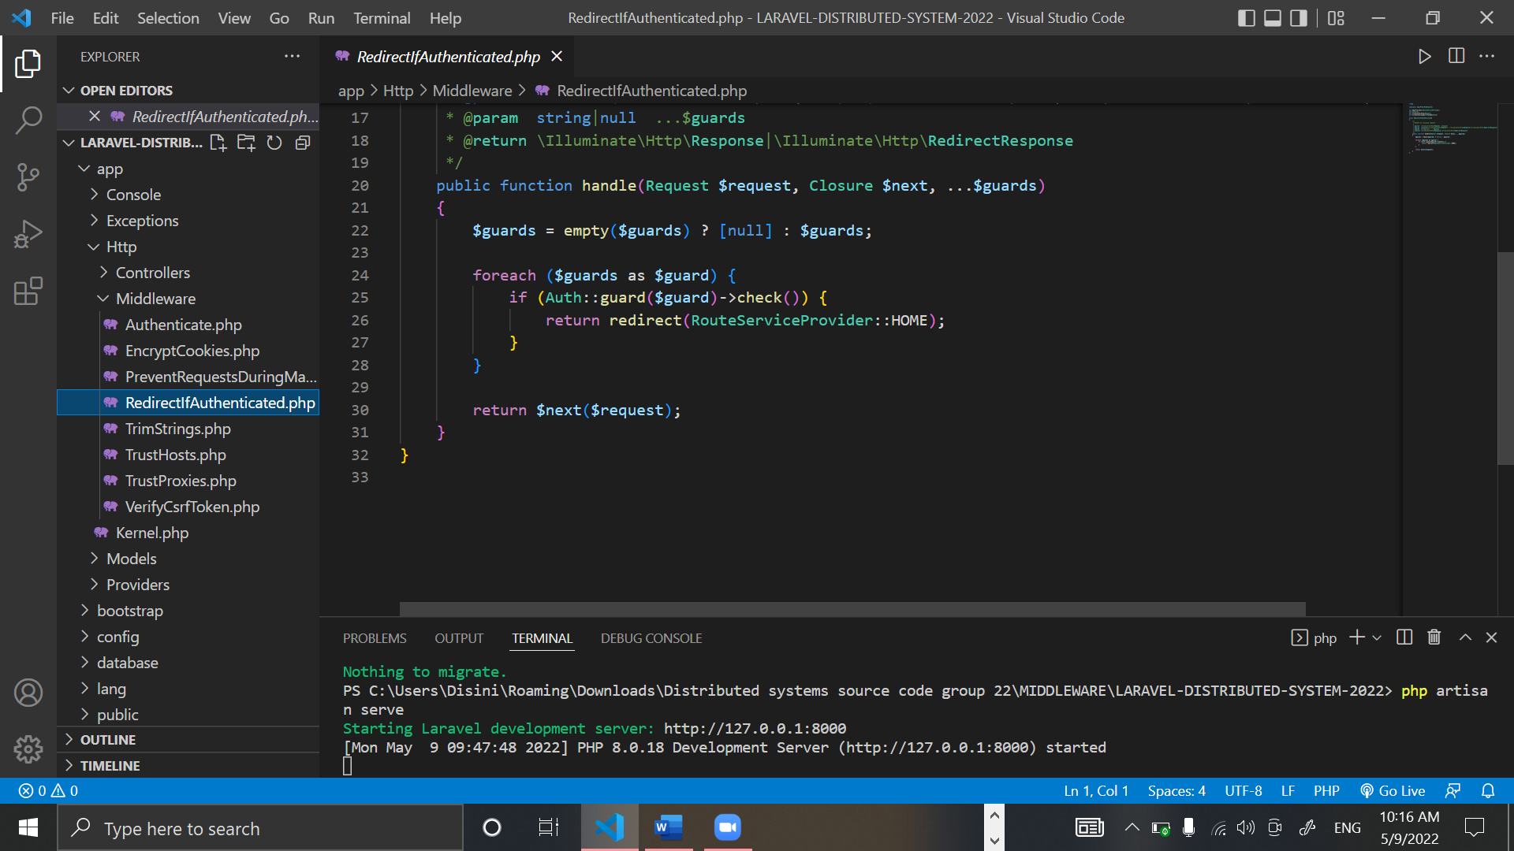

Figure 37: Redirectifauthenticated.php part 2

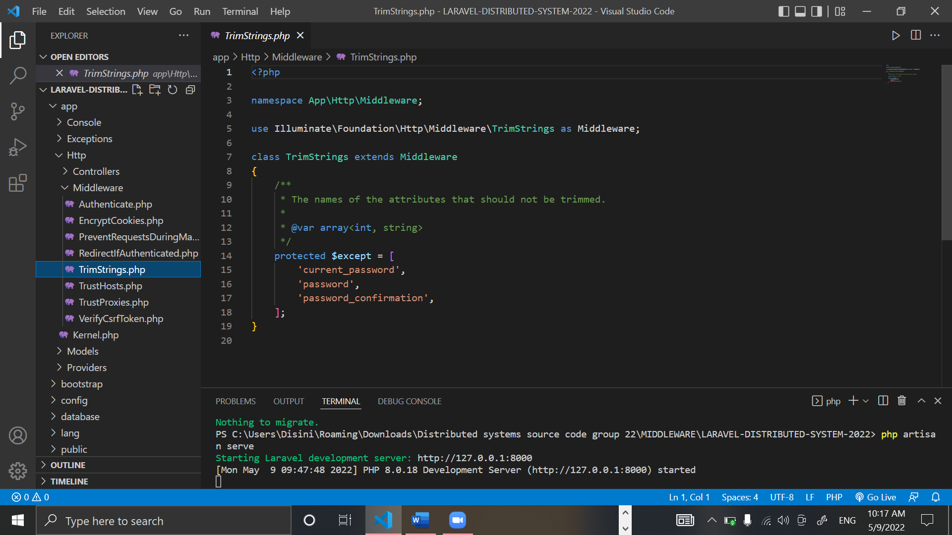

Figure 38: TrimStrings.php

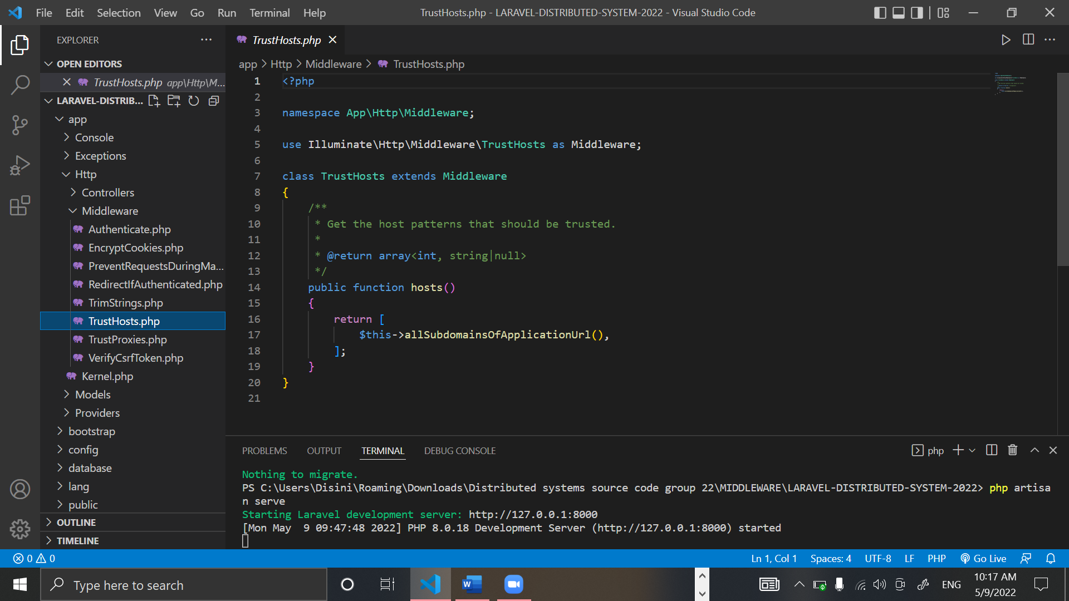

Figure 39: TrustsHosts.php

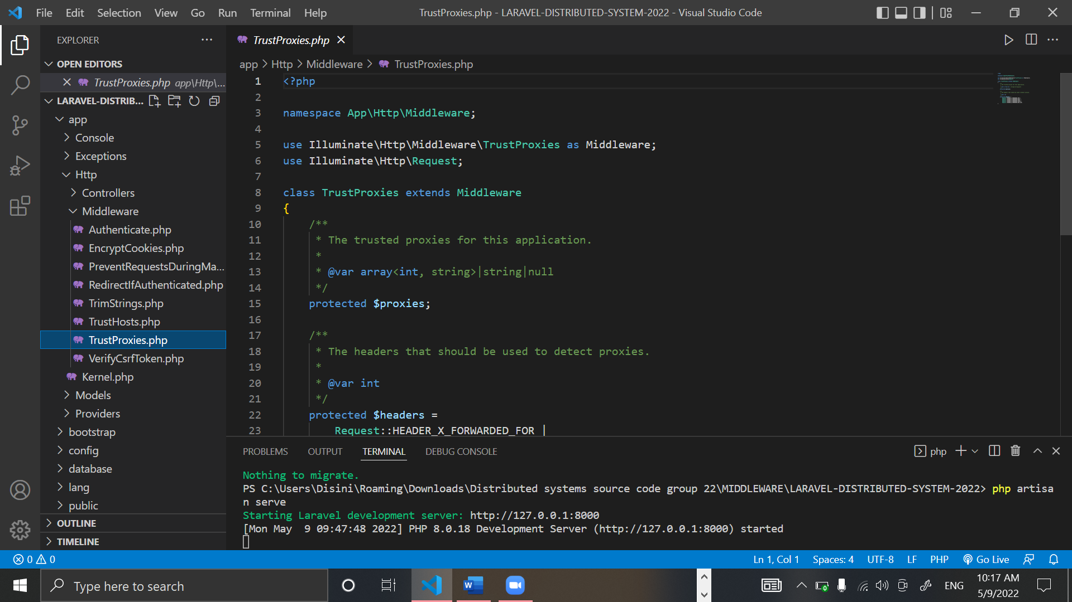

Figure 40: Trustproxies.php part 1

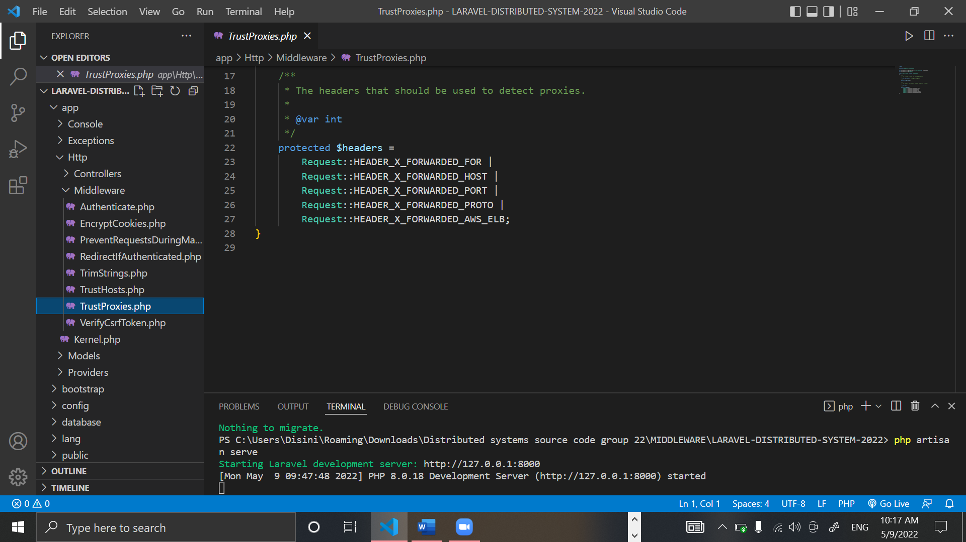

Figure 41: trustproxies.php part 2

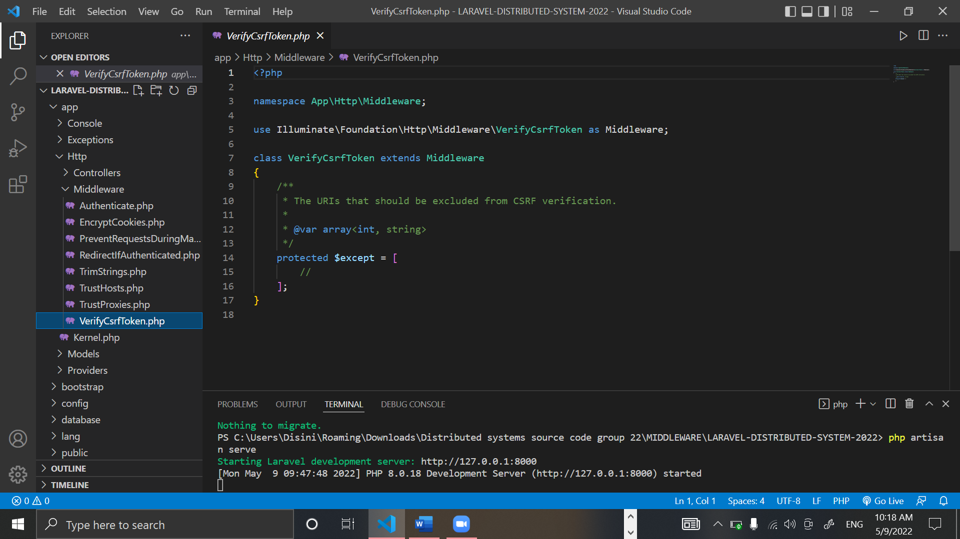

Figure 42: Verifycsrftoken.php

# Future enhancement of the system

We as a group would love to upgrade our project if we are to continue this project, this project is to be used by any person who has access to the internet. With this system people can focus and entail in their safety.

We would like to add features were the user can live forecasts and, we would love to add reports from weather stations into the systems, were people can be updated.

We would also like to enhance the project more with checking for weather patterns and collecting data for the betterment of human life.

# Risk assessment –

|  |  |
| --- | --- |
| Risk | Management Strategy |
| Data loss/technical failure | Backup and copy on a storage device. |
| Overrun on the schedule | The project plan now includes a contingency plan. Highlights and supervisor meetings will be used to track and monitor progress. More days have been added to the estimated completion dates for each step. |
| Complexity of the project | To adhere to a set of rules that would allow the basic functionality to be implemented and a working product to be produced. |
| Problems with the technology needed to complete the project | A basic prototype will be constructed for each phase to examine and validate validity. Maintaining a record of each stage. |
| Other requirements | There will be other projects operating concurrently, and this will receive full attention. A time management strategy would assist me in staying on track. |
| Lack of information on this topic | * Before starting, do a feasibility study on the topic. * Read books, essays, etc. on the topic. * Research on the internet. |
| Bad Timing | * Plan, then stick to it. * You must determine which project stages or components are most important to you, as well as the short, medium, and long-term impact of each stage/component. |
| Poor Code Quality | * Review of the code * Coding rules and guidelines that are easy to understand * All code is tested. * The Method of Work. |
|  |  |

Table 4: Risk Assessment

# Quality plan

|  |  |
| --- | --- |
| Unit Testing | Separate platforms and code blocks were tested in debug mode, bug fixing, and problems were resolved |
| Integrated Testing | In unit testing as shown with the screen shots of the working application the issues faced with the collaborative workload of the application were fixed and resolved |

Table 5: Quality Plan

# Summary -

# Individual contribution –

* J.A. Mujeeb (10707284) -
* G.M.D.D. Ratnayake (10707351) -
* S.O. Perera (10707315) -
* N. S. De Alwis (10707160) -
* M. D. A. Medhavi (10707278) -
* P. P. L. Dilhani (10709402)